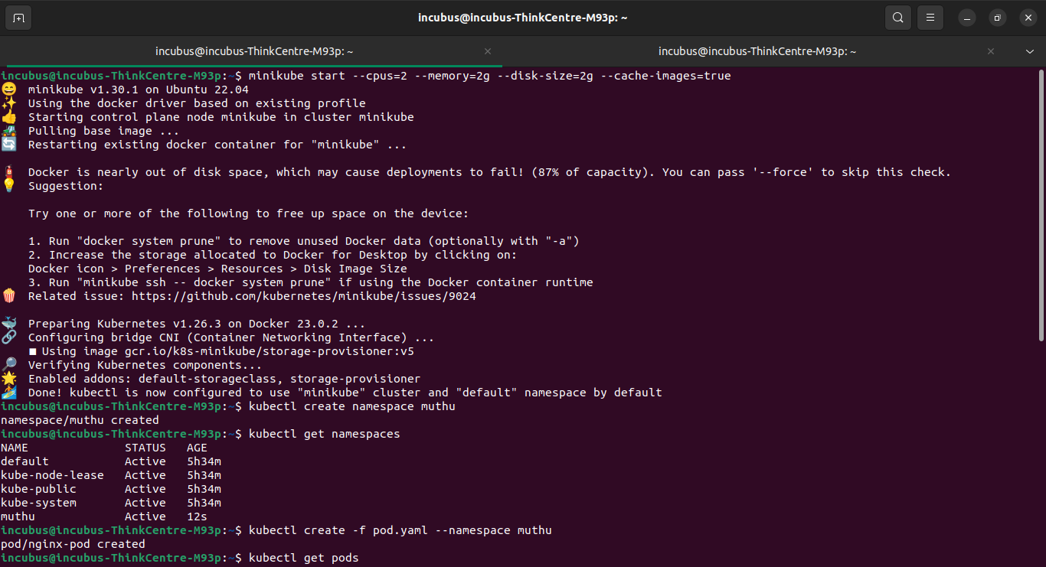
MINIKUBE INSTALLED AND STARTED IN MY LOCAL

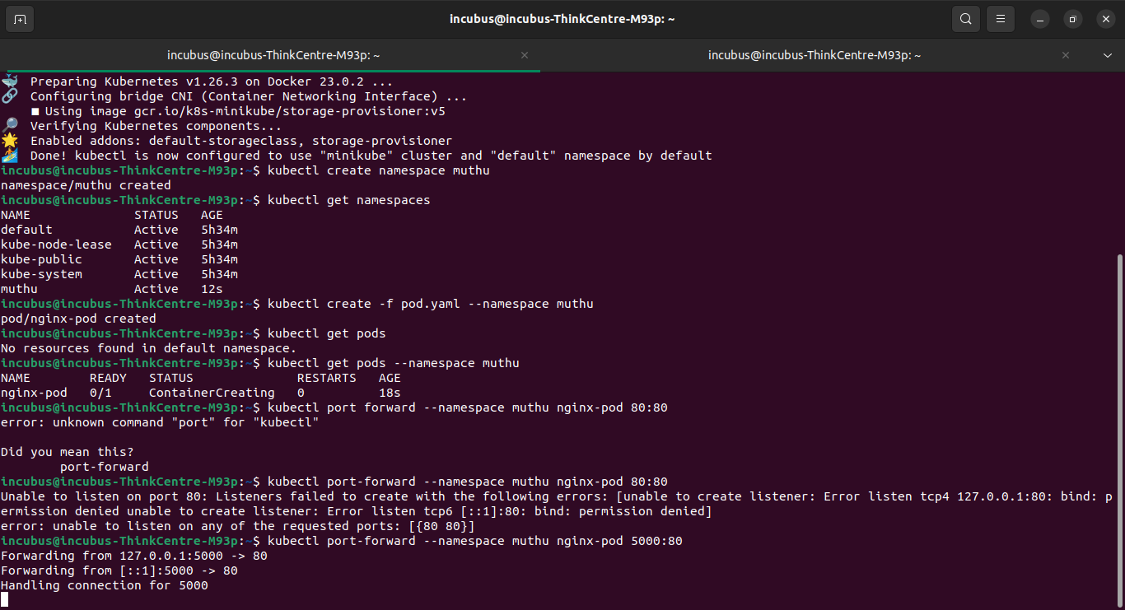
NAME SPACE CREATED

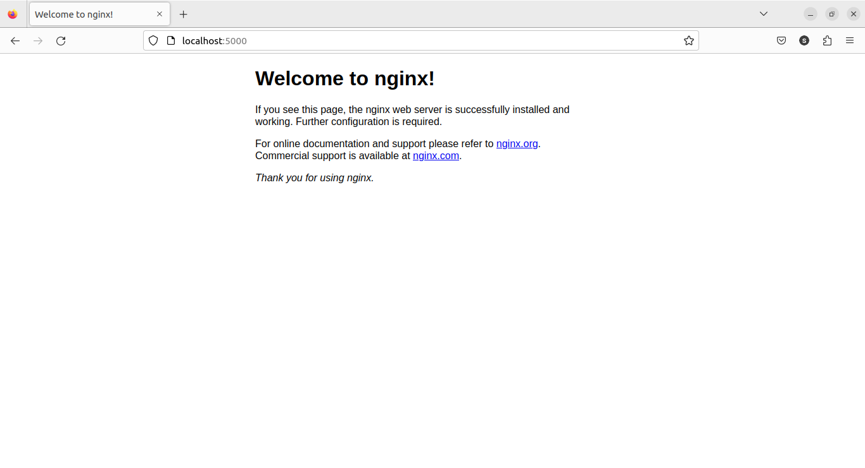
APPLICATION RUNNING INSIDE NAME SPACE ---- LOOK AT THE LOCAL HOST PORT

